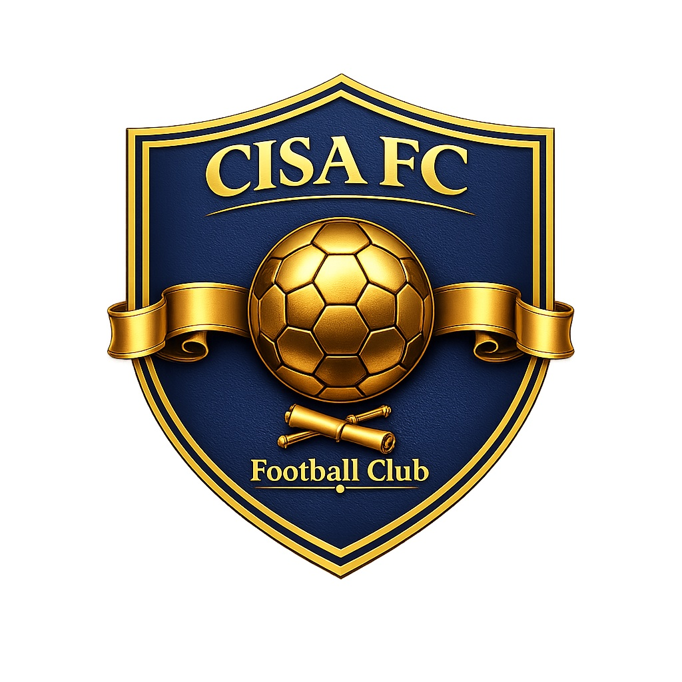

CONSTITUTION
of the
CHOKMAH INTERNATIONAL SPORTS ACADEMY
FOOTBALL CLUB
(CISA FC)

________________________________________________________________________________
Affiliated to the South African Football Association (SAFA)
Kempenville, Cape Town, South Africa

Adopted on: ____________________

TABLE OF CONTENTS
Article 1: Name, Emblem and Colours
Article 2: Registered Address
Article 3: Vision, Mission and Objectives
Article 4: Values and Ethos
Article 5: Affiliation
Article 6: Membership
Article 7: Membership Fees and Subscriptions
Article 8: Rights and Obligations of Members
Article 9: Termination and Suspension of Membership
Article 10: The Executive Committee
Article 11: Duties of Office-Bearers
Article 12: Executive Committee Meetings
Article 13: General Meetings
Article 14: Annual General Meeting
Article 15: Special General Meetings
Article 16: Voting
Article 17: Finance and Property
Article 18: Financial Year
Article 19: Code of Conduct and Discipline
Article 20: Grievance Procedure
Article 21: Amendments to the Constitution
Article 22: Dissolution
Article 23: General Provisions

________________________________________________________________________________
PREAMBLE
We, the members of the Chokmah International Sports Academy Football Club (hereinafter referred to as "CISA FC" or "the Club"), do hereby adopt this Constitution as the supreme governing document of the Club. CISA FC is the football division of the Chokmah International Sports Academy, operating under the umbrella of SPPS Chokmah Independent School.
Guided by the principle that faith, football, and academics are inseparable pillars of holistic youth development, we commit to nurturing disciplined, skilled, and values-driven young athletes who will serve as ambassadors of excellence on and off the field.
This Constitution shall be binding upon all members, players, coaches, officials, and any person associated with the Club. It shall be interpreted and applied in accordance with the rules and regulations of the South African Football Association (SAFA), the SAFA Cape Town Regional Football Association, and the Cape Winelands District Football Association, as applicable.
________________________________________________________________________________

Article 1: Name, Emblem and Colours
1.1. The name of the Club shall be the Chokmah International Sports Academy Football Club, abbreviated as CISA FC.
1.2. The official emblem of the Club shall be the CISA FC crest, comprising a navy shield bearing a gold football, the inscription "CISA FC" and "Football Club", and a gold scroll motif, as approved by the Executive Committee.
1.3. The official colours of the Club shall be:
(a) Navy blue (#0A1628) as the primary colour;
(b) Gold/Khaki (#C3B091) as the secondary accent colour;
(c) White (#FFFFFF) as the tertiary colour.
1.4. The Club's playing kit, training apparel, and official merchandise shall incorporate these colours as determined by the Executive Committee from time to time.
1.5. No alteration to the name, emblem, or colours of the Club shall be made except by a resolution passed by a two-thirds majority at a General Meeting.

Article 2: Registered Address
2.1. The registered address of the Club shall be:
Kempenville, Cape Town, Western Cape, South Africa
2.2. The official contact details shall be:
(a) Email: admin@chokmahcapetown.com
(b) Telephone: 021 065 1488
2.3. The registered address may be changed by resolution of the Executive Committee.

Article 3: Vision, Mission and Objectives
3.1. Vision: To be a leading football academy in South Africa, recognised for developing well-rounded athletes who excel in sport, academics, and character.
3.2. Mission: To provide a structured, faith-anchored environment where young footballers receive professional coaching, quality education (CAPS/IEB curriculum, Grades R-12), and comprehensive personal development to prepare them for careers in professional football and beyond.
3.3. The objectives of the Club shall be:
(a) To promote, develop, and administer the game of football in accordance with the Laws of the Game as determined by FIFA and SAFA;
(b) To provide professional football coaching and development programmes for players from grassroots to elite performance level;
(c) To integrate quality academic education with full-time football training through a flexible timetable model;
(d) To instil values of discipline, integrity, respect, teamwork, and faith in all participants;
(e) To develop pathways for talented players to progress into professional football, provincial teams, and national representation;
(f) To promote sports nutrition, physical wellness, and healthy lifestyles among members;
(g) To foster personal development, life coaching, and multiple-intelligence profiling for the holistic growth of each player;
(h) To participate in leagues, tournaments, and competitions sanctioned by SAFA and its affiliates;
(i) To uphold and advance the principles of fair play, non-discrimination, and inclusivity in all Club activities;
(j) To acquire, manage, and maintain facilities, equipment, and resources necessary for the fulfilment of the Club's mission.

Article 4: Values and Ethos
4.1. The Club is founded upon the principle that faith, football, and academics are complementary pillars of youth development.
4.2. All activities of the Club shall be conducted with integrity, respect for persons, and in a spirit of sportsmanship.
4.3. The Club affirms its commitment to:
(a) The spiritual and moral development of its members;
(b) Academic excellence alongside sporting achievement;
(c) Non-discrimination on the basis of race, gender, ethnicity, religion, or socio-economic background;
(d) The protection and safeguarding of children and vulnerable persons;
(e) Environmental responsibility and community service.

Article 5: Affiliation
5.1. The Club shall be affiliated to the South African Football Association (SAFA) and shall be bound by its constitution, statutes, regulations, and codes.
5.2. The Club shall register with and affiliate to the relevant SAFA Regional and/or District Football Association(s), including but not limited to the SAFA Cape Town Regional Football Association.
5.3. The Club shall comply with the rules and regulations of FIFA, the Confederation of African Football (CAF), and SAFA, and any amendments thereto.
5.4. The Club shall pay all affiliation fees, levies, and subscriptions required by SAFA and its affiliates in a timely manner.
5.5. Should a conflict arise between this Constitution and the constitution or regulations of SAFA, the SAFA constitution and regulations shall prevail.

Article 6: Membership
6.1. Membership of the Club shall be open to any person who supports the objectives and values of the Club, subject to the approval of the Executive Committee.
6.2. The following categories of membership shall exist:
(a) Player Members: Registered players participating in the Club's football programmes. Player Members under the age of 18 shall be classified as Junior Members, and their membership shall be subject to the consent of a parent or legal guardian.
(b) Coaching and Technical Staff: Qualified coaches, assistant coaches, and technical personnel employed or contracted by the Club.
(c) Administrative Members: Persons serving in administrative, managerial, or support roles within the Club.
(d) Honorary Members: Persons who have rendered distinguished service to the Club and are conferred honorary membership by the Executive Committee or a General Meeting. Honorary Members shall not be required to pay membership fees.
(e) Associate Members: Parents, guardians, sponsors, and supporters who wish to be formally associated with the Club.
6.3. All members shall be required to complete an official membership application form and agree to abide by this Constitution and the Club's Code of Conduct.
6.4. A register of members shall be maintained by the Secretary and shall be available for inspection by members at reasonable times.

Article 7: Membership Fees and Subscriptions
7.1. Membership fees, academy fees, and subscriptions shall be determined by the Executive Committee and ratified at the Annual General Meeting.
7.2. The Executive Committee may establish different fee structures for different categories of membership and for different programmes.
7.3. All fees shall be payable in advance at such intervals as determined by the Executive Committee.
7.4. The Executive Committee may, at its discretion, grant bursaries, fee reductions, or payment plans to members who demonstrate financial need, provided this does not jeopardise the financial viability of the Club.
7.5. Members who are in arrears with their fees for a period exceeding sixty (60) days may have their membership rights suspended until such arrears are settled.

Article 8: Rights and Obligations of Members
8.1. Every member in good standing shall have the right to:
(a) Participate in the activities and programmes of the Club, subject to selection policies and eligibility requirements;
(b) Attend and vote at General Meetings, provided they are 18 years of age or older and have been a member for at least thirty (30) days;
(c) Stand for election to the Executive Committee, subject to the eligibility criteria set out herein;
(d) Receive reasonable notice of meetings and access to minutes, financial statements, and this Constitution;
(e) Raise grievances through the established grievance procedure.
8.2. Every member shall be obliged to:
(a) Abide by this Constitution, the Club's Code of Conduct, and all lawful decisions of the Executive Committee and General Meetings;
(b) Pay all fees, subscriptions, and levies as and when due;
(c) Conduct themselves in a manner that upholds the good name and reputation of the Club;
(d) Comply with the rules and regulations of SAFA and its affiliates;
(e) Report any misconduct, safety concerns, or safeguarding issues to the appropriate Club official.

Article 9: Termination and Suspension of Membership
9.1. Membership shall be terminated upon:
(a) Written resignation submitted to the Secretary;
(b) Death of the member;
(c) Expulsion by resolution of the Executive Committee following a disciplinary process;
(d) Non-payment of fees for a continuous period exceeding ninety (90) days, after due notice.
9.2. The Executive Committee may suspend the membership rights of any member pending the outcome of a disciplinary hearing.
9.3. A member whose membership has been terminated or suspended may appeal to the Executive Committee in writing within fourteen (14) days of receiving notice of such termination or suspension.
9.4. No member whose membership has been terminated shall have any claim to the assets or property of the Club.

Article 10: The Executive Committee
10.1. The affairs of the Club shall be managed by an Executive Committee (hereinafter referred to as "the Committee" or "EXCO").
10.2. The Committee shall consist of the following office-bearers:
(a) Chairperson
(b) Vice-Chairperson
(c) Chief Executive Officer (CEO) and Director
(d) Secretary
(e) Treasurer
(f) Technical Director / Head of Football
(g) Up to three (3) additional members, as determined by the Committee
10.3. The founding CEO and Director of the Club shall be Mr Mncedisi Klaas.
10.4. Office-bearers (other than the CEO and Director) shall be elected at the Annual General Meeting and shall serve a term of two (2) years. Office-bearers shall be eligible for re-election.
10.5. A vacancy on the Committee arising between Annual General Meetings may be filled by the Committee through co-option, and the co-opted member shall serve until the next Annual General Meeting.
10.6. No person shall serve on the Committee who:
(a) Is under the age of 18 years;
(b) Has been declared insolvent or is under administration;
(c) Has been convicted of a criminal offence involving dishonesty, fraud, or violence;
(d) Is disqualified from holding office under the rules of SAFA.
10.7. The office of Chairperson and the office of CEO and Director may be held concurrently by the same person, where the General Meeting so resolves. Where the roles are so combined, the casting vote provided for in Article 12.3 shall not apply, and any deadlock shall be resolved by referral to a General Meeting.

Article 11: Duties of Office-Bearers

11.1 Chairperson
The Chairperson shall preside at all meetings of the Committee and General Meetings, ensure that the affairs of the Club are conducted in accordance with this Constitution, and represent the Club in official engagements. In the absence of the Chairperson, the Vice-Chairperson shall assume these duties.

11.2 CEO and Director
The CEO and Director shall be responsible for the overall strategic direction, day-to-day management, and operational leadership of the Club. The CEO and Director shall oversee the implementation of decisions made by the Committee and General Meetings, manage the Club's staff, and serve as the principal spokesperson of the Club.

11.3 Secretary
The Secretary shall be responsible for the administration of the Club, including maintaining the register of members, recording and distributing minutes of meetings, handling correspondence, ensuring compliance with affiliation requirements, and maintaining the official records of the Club.

11.4 Treasurer
The Treasurer shall be responsible for the financial management of the Club, including maintaining accurate books of account, preparing financial statements, presenting financial reports to the Committee and at General Meetings, managing the Club's bank accounts (jointly with at least one other designated signatory), and ensuring that all financial obligations are met.

11.5 Technical Director / Head of Football
The Technical Director shall be responsible for the football operations of the Club, including the design and implementation of coaching programmes, player development pathways, team selection policies, and the recruitment, management, and development of coaching staff.

Article 12: Executive Committee Meetings
12.1. The Committee shall meet at least once every calendar month, or as often as the business of the Club requires.
12.2. A quorum for Committee meetings shall be a simple majority of the members of the Committee, provided the Chairperson or Vice-Chairperson and at least one of the CEO/Secretary/Treasurer are present.
12.3. Decisions shall be taken by a simple majority of votes of those present. In the event of an equality of votes, the Chairperson shall have a casting vote.
12.4. The Committee may conduct meetings by electronic means (video or teleconference), and decisions taken at such meetings shall have the same validity as those taken at in-person meetings.
12.5. Minutes of all Committee meetings shall be recorded and maintained by the Secretary.

Article 13: General Meetings
13.1. A General Meeting is a meeting of all members of the Club who are entitled to vote.
13.2. The General Meeting shall be the supreme decision-making body of the Club.
13.3. Decisions of the General Meeting shall be binding on all members and the Committee.
13.4. A quorum for any General Meeting shall be twenty-five percent (25%) of the voting members of the Club, or fifteen (15) voting members, whichever is the lesser.
13.5. If a quorum is not present within thirty (30) minutes of the scheduled start time, the meeting shall be adjourned. If reconvened within fourteen (14) days, those present shall constitute a quorum.

Article 14: Annual General Meeting
14.1. The Annual General Meeting (AGM) shall be held once in every calendar year, not later than six (6) months after the end of the Club's financial year.
14.2. At least twenty-one (21) days' written notice of the AGM shall be given to all members.
14.3. The business of the AGM shall include:
(a) Confirmation of the minutes of the previous AGM and any subsequent Special General Meeting;
(b) Presentation and adoption of the Chairperson's report;
(c) Presentation and adoption of the CEO and Director's report;
(d) Presentation and adoption of the Treasurer's financial report and audited (or independently reviewed) financial statements;
(e) Election of office-bearers (in an election year);
(f) Appointment of an auditor or independent reviewer for the ensuing year;
(g) Determination of membership fees and subscriptions;
(h) Any other business of which due notice has been given.

Article 15: Special General Meetings
15.1. A Special General Meeting (SGM) may be convened by:
(a) A resolution of the Executive Committee; or
(b) A written petition signed by not fewer than one-third of the voting members of the Club, stating the purpose of the meeting.
15.2. At least fourteen (14) days' written notice of an SGM shall be given to all members, specifying the matters to be discussed.
15.3. No business other than that specified in the notice shall be transacted at an SGM.

Article 16: Voting
16.1. Each voting member present at a General Meeting shall have one (1) vote.
16.2. Voting shall ordinarily be by show of hands, unless a secret ballot is requested by at least ten percent (10%) of the members present and entitled to vote, or is required by this Constitution.
16.3. Proxy voting shall not be permitted.
16.4. Unless otherwise specified in this Constitution, resolutions shall be passed by a simple majority of votes cast.

Article 17: Finance and Property
17.1. The funds of the Club shall be derived from membership fees, academy fees, subscriptions, donations, sponsorships, grants, fundraising activities, and any other lawful sources approved by the Committee.
17.2. All funds of the Club shall be deposited in a bank account held in the name of the Club at a registered South African bank.
17.3. Cheques, electronic payments, and other financial instruments shall require the authorisation of at least two (2) of the following signatories: the Chairperson, the CEO and Director, the Treasurer, or the Secretary.
17.4. The funds and property of the Club shall be used solely for the advancement of the Club's objectives and shall not be distributed to members except as reasonable compensation for services rendered.
17.5. The Committee shall ensure that proper books of account are kept and that the Club's financial affairs are conducted transparently and in accordance with generally accepted accounting practices.
17.6. The Club's financial statements shall be independently reviewed or audited annually by a qualified person appointed at the AGM.

Article 18: Financial Year
18.1. The financial year of the Club shall run from 1 January to 31 December, unless otherwise determined by the Committee and ratified at a General Meeting.

Article 19: Code of Conduct and Discipline
19.1. All members, players, coaches, and officials shall adhere to the Club's Code of Conduct, which shall be adopted and amended by the Committee from time to time.
19.2. The Code of Conduct shall address, among other things:
(a) Respect for fellow members, opponents, match officials, and spectators;
(b) Prohibition of violence, harassment, bullying, and discrimination;
(c) Prohibition of the use of banned substances and compliance with anti-doping regulations;
(d) Respect for the property and facilities of the Club and host venues;
(e) Conduct on social media and in public that may reflect upon the Club.
19.3. Breaches of the Code of Conduct or this Constitution shall be dealt with through the Club's disciplinary procedure.
19.4. The disciplinary procedure shall include:
(a) Written notice of the charge(s) to the member concerned;
(b) The opportunity for the member to respond to the charge(s) and to be heard at a disciplinary hearing;
(c) A hearing before a disciplinary panel of at least three (3) members of the Committee (or persons appointed by the Committee) who have no conflict of interest in the matter;
(d) A written decision, with reasons, communicated to the member within fourteen (14) days of the hearing.
19.5. Sanctions may include a verbal or written warning, fine, suspension, or expulsion, as the disciplinary panel deems appropriate.
19.6. A member who has been sanctioned may appeal to the full Committee (excluding members of the disciplinary panel) within fourteen (14) days of receiving the decision. The appeal decision shall be final at Club level, without prejudice to any right of further appeal to SAFA structures.

Article 20: Grievance Procedure
20.1. Any member who has a grievance concerning the affairs of the Club may submit the grievance in writing to the Secretary.
20.2. The Secretary shall refer the grievance to the Chairperson, who shall appoint an appropriate person or panel to investigate and mediate.
20.3. The Club shall endeavour to resolve grievances informally and amicably in the first instance.
20.4. If the grievance cannot be resolved informally, it shall be referred to the Committee for a formal decision, which may be appealed to a General Meeting.

Article 21: Amendments to the Constitution
21.1. This Constitution may be amended by a resolution passed by a two-thirds majority of the voting members present at a General Meeting.
21.2. Proposed amendments must be submitted in writing to the Secretary at least twenty-one (21) days before the General Meeting at which they are to be considered.
21.3. The Secretary shall circulate the proposed amendments to all members at least fourteen (14) days before the meeting.
21.4. No amendment shall take effect until it has been ratified by the relevant SAFA structure(s), where such ratification is required.

Article 22: Dissolution
22.1. The Club may only be dissolved by a resolution passed by a three-quarters majority of the voting members present at a Special General Meeting called for that purpose, of which at least twenty-one (21) days' notice has been given.
22.2. Upon dissolution, the assets of the Club remaining after the satisfaction of all debts and liabilities shall not be distributed to members, but shall be transferred to:
(a) Another SAFA-affiliated football club or football development organisation; or
(b) A registered non-profit organisation with objectives similar to those of the Club,
as determined by the General Meeting at the time of dissolution.
22.3. Notice of dissolution shall be communicated to SAFA and the relevant regional/district football association(s) within thirty (30) days.

Article 23: General Provisions
23.1. The Club shall at all times act in accordance with the laws of the Republic of South Africa.
23.2. The Club shall maintain appropriate insurance for its activities, where reasonably practicable.
23.3. The Club shall comply with all child safeguarding legislation and best practices, and shall implement a child protection policy.
23.4. Members of the Committee shall not be personally liable for the debts or obligations of the Club, provided they have acted in good faith and within the scope of their authority.
23.5. Any matter not provided for in this Constitution shall be dealt with by the Committee, subject to the overriding provisions of the SAFA constitution and the laws of South Africa.
23.6. In the event of a dispute regarding the interpretation of this Constitution, the decision of the Chairperson shall prevail, subject to the right of any member to refer the matter to a General Meeting for final determination.

________________________________________________________________________________
ADOPTION AND SIGNATURES
This Constitution was duly adopted at a General Meeting of the Chokmah International Sports Academy Football Club held at ______________________________ on the ________ day of __________________ 20______.
Signed by the following office-bearers on behalf of the Club:

________________________________________
Chairperson
Date: ______________________

________________________________________
CEO and Director (Mr Mncedisi Klaas)
(Same person as Chairperson, holding both offices concurrently in terms of Article 10.7)
Date: ______________________

________________________________________
Secretary
Date: ______________________

________________________________________
Treasurer
Date: ______________________

